**Chapter 1**

**Introduction to Web based Vehicle Tracking System**

* 1. **Introduction**

This chapter mainly conveys the information about the functionality and the performance of the system that we are going to implement. And this system is going to be designed for a request of our client, Ridgecrest (pvt) Ltd. As we are living in a timeless era, everyone is suffering from lack of time in order to fulfill their own needs. Most of the people in Sri Lanka are used to use own vehicles and others are working as drivers. In case those people forget to renew their documents, their vehicles may get struck half way and they may find difficult to settle their payments instantly if they need. So we are introducing an innovative “Vehicle Tracking System” to solve these problems. We are expecting to promote a website which is more portable with and using Unicode to develop our system. It will provide solution for the user to track the vehicle anywhere to find a way keeps records of whole details about the vehicle and the owner and provide user alerts to update them, help to find a suitable service center and provide the user to access online payment methods.

* 1. **Background and motivation**

Here we are combining the use of automatic vehicle location in individual vehicles with software that collects fleet data for a of vehicle locationsto facilitate user anywhere and anytime view it in a map. Today people are very busy. Some people forgot to pay attention about their vehicles maintaining. If they have more vehicles they can’t get all details in easy manner. So we have motivated to do this project with many more facilities on vehicle tracking system .We build a web site for people who use vehicles and can access the proposed system anywhere. By using this web site they can add their vehicle’s all details and they can maintain all payable and renew documents on this website. If they handling our website we facilitate to auto renew their vehicle document as well. They can pay vehicle’s insurances by using this web site. It will link all payable options, payable amounts and payable companies from a one website. Especially it will focus all vehicle owners’ lives in any area. Even he is a taxi driver; he also can use this website and can maintain his vehicle document. It also will support for mobile phones and this website have another facility that refer most appropriate service center for the user.

* 1. **Problem in brief**

Nowadays most people use vehicles for their personal and other daily activities. As well as most people use a vehicle tracking system for their vehicles and there are many vehicle tracking systems and devices in the world. The current tracking systems are mainly carried out using GPS technology. By using that technology can determine the whereabouts of their vehicle at any given time. And if the user want to check miles that he/she driven and to get the fuel count, this can be used for that purpose also. If someone is an employer or owner of a fleet company, e.g.: taxi, delivery van, public bus etc., and then they should be using vehicle tracking systems in their business. Further if some person uses a personal vehicle, his also can use this vehicle tracking system for his vehicle. Even families which using many vehicles they can use these system as well. Because their busily life style sometimes they haven’t time for pay attention about maintain their vehicles. Sometime they haven ‘and don’t know all details of their vehicles. People who using many vehicles in family, they can’t maintain all vehicle’s document of their vehicles. Even a company they also can’t maintain all vehicle’s detail that they have. Monthly they have to pay insurances payable for insurance company. As well as they should annually renew their driven and vehicle license. Further they have to pay for vehicle income license as well. But sometimes vehicle owners can’t pay time to do these things. They should do these things from different places and different ways. Therefore we mostly pay attention for that situation.

**1.4 Aim and Objectives**

**1.4.1 Aim**

This project aims to reduce the time consuming when getting services related to vehicles by creating a system which portable for any device to people who can track everything about vehicles.

**1.4.2 Objectives**

* Design and develop a system to solve the problem
* Study the technology (GPS/GSM module) which we are going to use, and use them in

the system

* Create a website and make it portable for any device which can track everything about vehicles
* Use all appropriate web based technology (PHP/JavaScript/HTML) and proper
* database management system
* Finally to deliver a system which is most efficient and appropriate solution for the

Problem

* To make a user manual for further work
* Preparation of final documentation

**1.5 Solution in terms**

**1.5.1 Users**

Solution for the above problem can be interpreted by this manner, where two parties are suffering from this problem. One is the vehicle owner, other one is the service provider. And they can be categorized as

* Service provider
* Service obtainer

Service providers are defined as any organization that is willing to give services related to vehicles.

Service obtainer is the user of the system mostly and someone who need services related to their vehicles.

**1.5.2 Inputs**

All the input for this system is taken through users and service providers , they are stored in a My sql database. Using PHP as the server side scripting language. Service contains a content management system for service providers and users to publish and store their work easily.

**1.5.3 Outputs**

Using advance search option user can filter and search for the best possible service for their need. Service providers can select a desired template to publish their information much more easily in the web page.

**1.5.4 Process**

Using HTML5 CSS and JavaScript user interfaces are designed to take user inputs and using PHP as the backend those information are stored in a MYSQL database. Especially we are going to use php frame work php (codeignater) for developing. And bootstrap css frame work for responsiveness in mobile devices.

### 1.5.5 .Technology

User interfaces are designed by HTML CSS and JavaScript. Using Bootstrap, responsive web service. Backend designed with codeinnaitor using php and database designed with MYSQL.

### 1.5.6. Features

* Content management system for service providers.
* Different templates for service providers.
* Complete profile for users.
* Reference guide for choosing appropriate service center
* Alerts and notifications via email

### 1.5.7. System requirement

* Internet connection
* Web browser

**1.6 Proposed solution**

As the solution for the above problem, we proposed a web based management system which is more portable for any device. This web based management system will maintain all the information about vehicles. Such as driving license of drivers, insurance of the vehicle, finance of the vehicle, etc.

In this web based management system we can maintain and update all of these things. Like update driving license, insurance of the vehicle etc. We can identify where our vehicle is now, by using these app. We used GPS system for this. We record everything about the vehicle. Like insurance, license, lease, legal document about the vehicle etc.. Then we send a message to the user about these documents, if there is any update or renew or payment. So user can do it through our web site.

We add vehicle service station details in our web site. So vehicle owner can reserve time slots through the web site. So users no need to wait in service station. This is save users time.

The most important thing is we implemented site supports Sinhala language. So this web site is focused not only Colombo people, but also Anuradhapura, Gall like other out of Colombo cities. That means this web site can use anyone, and it is very user friendly.

**Simple data flow diagram with frontend and backend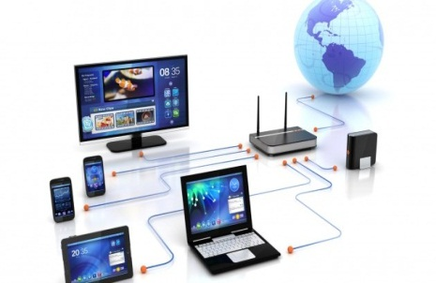 of the proposed system**

Website & Android app

Web browsing

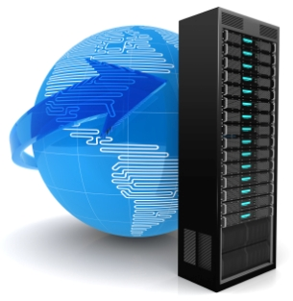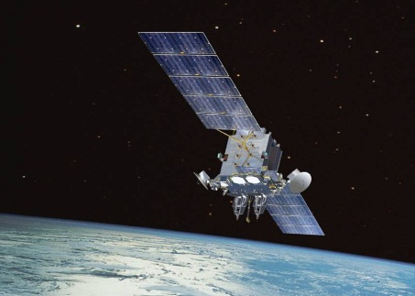

Web & Server side

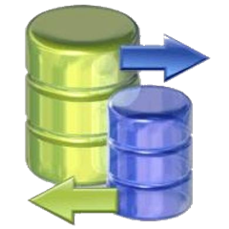



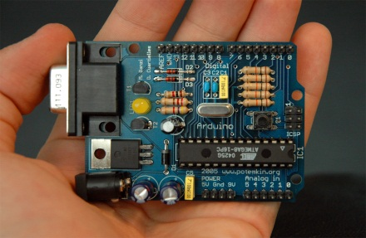

Database

Vehicle with Arduino circuit

Figure 1.1

### 1.6.1. Summary

This chapter mainly focuses on introduction to this system including system’s inputs, outputs, and the process.

**Chapter 2**

# Review of Others Work

## 2.1 Introduction

The Vehicle tracking system and vehicle details management web site in our study is designed to provide facilities to people who have vehicles. Apart from the old system, this new system is designed to manage vehicle’s details and documents by an automated system without wasting vehicle owner’s time and provide facilities to track the vehicles on the way.

This chapter will present the systems that are similar or within the study area of the vehicle tracking system and vehicle document management system, the technologies, frameworks they have used. While describing them it will include the similarities and differences of those system comparisons to vehicle tracking system and vehicle documents management system and the drawback and the advantages which have arisen due to those.

## 2.2 Similar Approaches

There are many existing vehicle tracking systems and vehicle document management systems today. We will attempt to create a vehicle tracking system and web based management system from a unique way. This is a brief overview of the similar systems and a discussion about the features developed which are different from vehicle tracking system and vehicle’s document management system. The privileges those changes have brought to this system and the drawbacks that are arisen due to them.

1. Open GPS tracking system
2. Vehicle Management System
3. GPS/GSM tracking system using Telit GM862 module
4. Track Port GPS Vehicle Tracker

**2.2.1 GPS/GSM tracking system using Telit GM862 module**

This software is a vehicle tracking system application which kind of a mobile tracker. This also used GPS/GSM technologies as our mobile android application. This device can be put in the car and it could trigger an alarm, if the car got stolen. It actually could tell vehicle where it is.

**2.2.2 Vehicle Management System**

The vehicle management system is an application for the automotive industry. Mostly it support in the area of Sales & Services, It helped to record and manage all details and documentation of the vehicle which are sell. It also supports the archiving of vehicle data. Actually it will manage and make easy to all services of a business.

The dealers can log in to that system remotely via Internet and access your data. User only needs an Internet browser.

**2.2.3 Open GPS tracking system**

Open GPS tracking system is the first available open source project designed specifically to provide web-based GPS tracking services for a "fleet" of vehicles.  
It can be use the types of vehicles and assets tracked include taxis, delivery vans, trucks/trailers, farm equipment, personal vehicles, service vehicles, containers, ships, ATVs, personal tracking, cell phones, and more. While Open GPS tracking was designed to fill the needs of an entry-level fleet tracking system; it is also very highly configurable and scalable to larger enterprises as well.

**2.2.4 Track Port GPS Vehicle Tracker**

The Track Port GPS Vehicle Tracker allows tracking the GPS location of a connected vehicle online. People can set it to send E-mail alerts when the vehicle exceeds a certain speed or enters or exits a geofenced area. Powered by the car's OBD-II port, the Track Port is plug-and-play. This GPS Vehicle Tracker is easy to install and use and people can monitor the position and status of almost any car via its Web portal.

## 

## 2.3 Summary

Unlike our vehicle tracking system and web based vehicle document management system, Vehicle management system has some aspects. It is most suitable for a vehicle service and ­­­sales centres. But our Vehicle tracking System and Vehicle Details Management System can use for any companies, persons and families. It can be also use for any vehicle owners which have any vehicle even if it is a three wheel or bike or any other vehicles. Due to use Unicode for the web application it wills most user friendly for any peoples. Especially we have some facilitated to send user alerts regarding to dates which should documents update and renew other than that existing systems.

Regarding to other GPS/GSM used vehicle tracking systems which is open GPS tracking system, there are some differences and similarities of our vehicle tracking system. Same as we have system to develop find location from Google map after tracking vehicle on the way. But we haven’t facilitated to tack fleet of the vehicle.

Our mobile application of vehicle tracking system and web based management system can support any versions of mobiles and internet browsers. Comparing to track port GPS vehicle tracker, it is No standalone smartphone apps are available. The monthly monitoring fee is a bit pricey. As well as the online interface can be unintuitive.

**Chapter 3**

**Usage of Technologies in VTS**

**3.1 Introduction**

This chapter describes about the technologies and techniques which we have used to solve the problem. This is a brief description of those technologies that we used for the implementation of VTS. In order to implement those technologies we have to learn most of the technologies. We have to use lots of new technologies as well as old technologies too.

**3.2 Technologies Adopted**

Since this system is a web-based application, it must be capable with handling many web requests from users. So in developing this system we mainly considered on following technologies.

1. Global Positioning System (GPS)
2. General Packet-Radio System (GPRS)
3. Transmission Control Protocol (TCP)
4. GPS / GPRS combined modules
5. Socket Programming
6. Web Technologies (PHP, JavaScript, HTML, My SQL )

**3.2.1 Global Positioning System (GPS)**

The Global Positioning System (GPS) is a space-based satellite navigation system that provides location and time information in all weather conditions, anywhere on or near the Earth where there is an unobstructed line of sight to four or more GPS satellites. The system provides critical capabilities to military, civil and commercial users around the world. It is maintained by the United States government and is freely accessible to anyone with a GPS receiver. The GPS program provides critical capabilities to military, civil and commercial users around the world.

The satellites are spaced in orbit so that at any time a minimum of six satellites will be in view to users anywhere in the world. The satellites continuously broadcast position and time data to users throughout the world. The GPS satellites transmit signals to a GPS receiver. These receivers passively receive satellite signals; they do not transmit and require an unobstructed view of the sky, so they can only be used effectively outdoors. Early receivers did not perform well within forested areas or near tall buildings but later receiver designs such as SiRFStarIII, MTK etc have overcome this and improved performance and sensitivity markedly. GPS operations depend on a very accurate time reference, which is provided by atomic clocks on board the satellites. By capturing the signals from three or more satellites (among a constellation of 31 satellites available), GPS receivers are able to use the principle of trilateration to pinpoint a location.

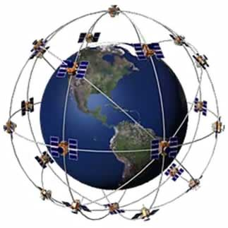

Figure 3.1: GPS Constellation visual example

**3.2.2 General Packet-Radio System (GPRS)**

The GPRS core network is the central part of the general packet radio service (GPRS) which allows 2G, 3G and WCDMA mobile networks to transmit IP packets to external networks such as the Internet. The GPRS system is an integrated part of the global system for mobile communications (GSM) network switching subsystem**.** This technology was originally standardized by European Telecommunications Standards Institute (ETSI) in response to the earlier CDPD and i-mode packet-switched cellular technologies and now it is now maintained by the 3rd Generation Partnership Project (3GPP).

The main benefits of GPRS are that it reserves radio resources only when there is data to send and it reduces reliance on traditional circuit-switched network elements. The increased functionality of GPRS will decrease the incremental cost to provide data services, an occurrence that will, in turn, increase the penetration of data services among consumer and business users. In addition, GPRS will allow improved quality of data services as measured in terms of reliability, response time, and features supported. The General Packet Radio Service (GPRS) is a new non voice value added service that allows information to be sent and received across a mobile telephone network. It supplements today’s Circuit Switched Data and Short Message Service. GPRS is NOT related to GPS (the Global Positioning System), a similar acronym that is often used in mobile contexts.

In addition to providing new services for today’s mobile user, GPRS is important as a migration step toward third-generation (3G) networks. GPRS will allow network operators to implement a IP-based core architecture for data applications, which will continue to be used and expanded upon for 3G services for integrated voice and data applications. In addition, GPRS will prove a testing and development area for new services and applications, which will also be used in the development of 3G services.

**3.2.3 Transmission Control Protocol (TCP)**

The Transmission Control Protocol (TCP) is one of the core protocols of the Internet protocol suite (IP), and is so common that the entire suite is often called TCP/IP. TCP provides reliable, ordered and error-checked delivery of a stream of octets between programs running on computers connected to a local area network, intranet or the public Internet. It resides at the transport layer.

The protocol corresponds to the transport layer of TCP/IP suite. TCP provides a communication service at an intermediate level between an application program and the Internet Protocol (IP). That is, when an application program desires to send a large chunk of data across the Internet using IP, instead of breaking the data into IP-sized pieces and issuing a series of IP requests, the software can issue a single request to TCP and let TCP handle the IP details. IP works by exchanging pieces of information called packets. A packet is a sequence of octets (bytes) and consists of a header followed by a body. The header describes the packet's source, destination and control information. The body contains the data IP is transmitting.

**3.2.4 GPS / GPRS combined module**

This is the main device which is attached to each prime mover for tracking its route. This module is capable of getting the current location coordinates of the prime mover by using the GPS service and send those coordinates to a remote server wither using SMS alerts over GSM or TCP connection via GPRS. For this project as it works as a real time tracking system we prefer TCP connection via SMS between the GPS / GPRS module and the remote server because SMS delivery over GSM maximum of 10 per minute. The device incorporates a covertly installed module (which works and communicates independently) but has the ability to run in conjunction with your local GSM network (DTMF, voice message, SMS, GPRS or GSM modem call). The tracking centre operator monitors your vehicle 24 hours per day for unauthorised intrusion, theft, accident, breakdown, panic/assistance, vehicle movement or breach of a predefined "Geo -fence" boundary. The operator can then perform numerous tasks including; engine immobilisation, unlock doors, advise the police or dispatch security response.

**3.2.5 Socket Programming**

For network communication to take place between two processes, each process requires an end point to establish a communication link between the two processes. This end point, called a socket, sends messages to and receives messages from the socket associated with the process at the other end of the communication link. Socket programming is also known as Computer Network programming and our location coordinates receiving serve is programmed using these technologies to get the location coordinates form each of GPS / GRPS modules. Socket refers to an IP address of a computer which is connected to a network and a port number of and specific application which is in IP:Port format. The GPS / GPRS module is capable of sending its data to a specific socket using TCP connection via GPRS.

**3.2.6 Web Technologies**

In developing this project we used PHP language for Server Side Web Scripting and JavaScript, HTML for the Client Side Web Scripting.

### PHP

PHP is a server-side scripting language designed for web development but also used as a general-purpose programming language. PHP is now installed on more than 244 million websites and 2.1 million web servers. Originally created by Rasmus Lerdorf in 1995, the reference implementation of PHP is now produced by The PHP Group. While PHP originally stood for Personal Home Page, it now stands for PHP: Hypertext Preprocessor, a recursive acronym.

### Bootstrap

Bootstrap is an open-source Javascript framework developed by the team at Twitter. It is a combination of HTML, CSS, and Javascript code designed to help build user interface components. Bootstrap was also programmed to support both HTML5 and CSS3.Bootstrap has relatively incomplete support for HTML5 and CSS 3, but it is compatible with all major browsers. Basic information of compatibility of websites or applications is available for all devices and browsers. There is a concept of partial compatibility that makes the basic information of a website available for all devices and browsers. For example, the properties introduced in CSS3 for rounded corners, gradients and shadows are used by Bootstrap despite lack of support by older web browsers. These extend the functionality of the toolkit, but are not required for its use. Since version 2.0 it also supports responsive design. This means the graphic design of web pages adjusts dynamically, taking into account the characteristics of the device used (PC, tablet, mobile phone).Bootstrap is open source and available on GitHub. Developers are encouraged to participate in the project and make their own contributions to the platform.

### CSS

Cascading Style Sheets (CSS) is a style sheet language used for describing the presentation semantics (the look and formatting) of a document written in a markup language. Its most common application is to style web pages written in HTML and XHTML, but the language can also be applied to any kind of XML document, including plain XML, SVG and XUL.CSS is designed primarily to enable the separation of document content (written in HTML or a similar markup language) from document presentation, including elements such as the layout, colors, and fonts. This separation can improve content accessibility, provide more flexibility and control in the specification of presentation characteristics, enable multiple pages to share formatting, and reduce complexity and repetition in the structural content (such as by allowing for table less web design). CSS can also allow the same markup page to be presented in different styles for different rendering methods, such as on-screen, in print, by voice (when read out by a speech-based browser or screen reader) and on Braille-based, tactile devices. It can also be used to allow the web page to display differently depending on the screen size or device on which it is being viewed. While the author of a document typically links that document to a CSS style sheet, readers can use a different style sheet, perhaps one on their own computer, to override the one the author has specified.

### HTML

Hypertext markup language can be considered as the backbone of user interfaces. All the basic interfaces and webpages are designed basically with the aid of html.Hyper Text Markup Language (HTML) is the main markup language for creating web pages and other information that can be displayed in a web browser.HTML elements form the building blocks of all websites. HTML allows images and objects to be embedded and can be used to create interactive forms. It provides a means to create structured documents by denoting structural semantics for text such as headings, paragraphs, lists, links, quotes and other items. It can embed scripts written in languages such as JavaScript which affect the behavior of HTML web pages.Following its immediate predecessors HTML 4.01 and XHTML 1.1, HTML5 is a response to the observation that the HTML and XHTML in common use on the World Wide Web are a mixture of features introduced by various specifications, along with those introduced by software products such as web browsers, those established by common practice, and the many syntax errors in existing web documents. It is also an attempt to define a single markup language that can be written in either HTML or XHTML syntax. It includes detailed processing models to encourage more interoperable implementations; it extends, improves and rationalizes the markup available for documents, and introduces markup and application programming interfaces (APIs) for complex web applications. For the same reasons, HTML5 is also a potential candidate for cross-platform mobile applications.

**3.2.7 Database Management Technologies**

When the remote server gets data from the GPS module for the later use of that data, it needs to be stored in some database. For that we used some database which is created from MySQL language to store data when received and retrieve those stored data when requested by the user.

**3.3. Summary**

In developing of Vehicle Tracking System (VTS) we had to learn and get a vast knowledge on new technologies like GPS, GNSS and as well as the old technologies like GPRS, TCP, Web Technologies and Socket Programming etc.

**Chapter 4**

**Our Approach**

**4.1 Introduction**

This chapter mainly describes about the approaches that the system went through to overcome the problem with vehicle tracking system, the steps followed when implementing the proposed solution, how each technology use to our model and the detail description about our product is given

The proposed solution is basically a web based application which contains login part for the user, view the updates of his vehicle details such as the renewal date of vehicle license, driving license, amounts of insurance and taxes which have to be paid, search the service station which is near to the location and less cost.

**4.2 Progress of the System**

This system contains with web service, web application and the database.The user is capable of using a web-browser, and is capable of browsing through web pages. If the web server is working properly, the Internet connection allows the system to perform all necessary tasks.

Web application is being created using joomla and hand coding part of the application was done using dreamweaver and PHP. The database which is connected to the web application was created in Apache server and managing the database is essential to keep data security and the safety of the data which user entered. When user request the url home page is shown and then user has to enter user name and the password and login to the system. Then user can find the location, service station which is near to the location.

We are planning to improve our system with Apache serverfor the web service because of having supportive XML base web service frame work.Ability to validating details was important in web applications. So the Apache serverhas the capability of validating was useful.The acronym WAMP refers to a set of free (open source) applications, combined with Microsoft Windows, which are commonly used in Web server environments. The WAMP stack provides developers with the four key elements of a Web server: an operating system, database, Web server and Web scripting software. The combined usage of these programs is called a server stack. In this stack, Microsoft Windows is the operating system (OS), Apache is the Web server, MySQL handles the database components, while PHP represents the dynamic scripting languages.The device isattached with the moving object and gets the position fromGPS satellite in real-time. It then sends the positioninformation with the International Mobile EquipmentIdentity (IMEI) number as its own identity to the server. Thedata ischecked for validity and the valid data is saved into thedatabase. When a user wants to track the device, s/he logsinto the service provider’s website and gets the live positionof the device on Google Map. A custom report is alsogenerated which includes a detailed description of thevehicles status.



Figure 4.1:Detailed description of the vechile status

The socket communication server is the central server component that communicates with the tracking units. It establishes TCP/IP socket connections with the remote hardware units. It is capable of communicating with multiple client units using multiple threads. A custom-defined application level protocol is used for transfer of data. The TCP sever will create a TCP socket and will bind the application to the relevant port. It will then listen to any incoming connections from that socket

**Chapter 5**

**Analysis and Design**

## 5.1 Introduction

Delivering a good product to the customer, we should understand exact requirements of the customer. For the success of a project, analysis phase in the system development life cycle is a very important factor. This chapter mainly describes about the analysis and design of the proposed solution thatwe are going to made, the analysis that has done when developing the system and design of the solution. Basically this chapter will discuss about the analytical background of the project. It also includes the main structure of the system.

## 5.2 Analysis

The analysis part identifies what the system must do, irrespective of the technology and management. It discovers and understands the requirements and includes decision on the system's scope and also how should it behave. Designing part is useless work without having clear understanding of the requirements. The output from analysis is a Conceptual Model.

### 5.2.1 Requirement Analysis

Under this section a detailed system study was carried out of the existing systems, and how do they work, what are they functionality.

The following methodologies that are we used for the gathering information.

* Interviews
* Review of the current system

#### 5.2.1.1 Interviews

Interviews are carried out the user requirements. When we talk with our customer, we can gather information, what they want. Mr.Sanath Fernando is our customer, and he gave us some points that he exactly want. But when we talk with him, he gave us lots of information. When we talk with our supervisor Miss.Kaushalya Kumarashinghe gave us some technological information, and then Mrs.Ruwini Weerasinghe gave us marketing information. Then the owner of the vehicle, is the another party that we are used to collect information.

**5.2.1.2 Review of the current system**

In this method interfaces and the functionalities in the current system was reviewed to gain insight in to the process.

Interviewsand review of the current system helped to identify the following problems.

* Updating legal documents of the vehicle, may be forget them,
* Owner of the vehicle wants to know where is the his vehicle (at the time, another person will drive the vehicle)
* People can’t wait at the service station. Because they haven’t enough time for that.

After gathering requirements and analyzing them system was visually modeled with the help of UML tools and OOAD concepts to get an overview of the system.

**5.2.2 Use case model of the system**

In the use case model of the system, that consists of actors' and goals that interact with the system. Following are the use cases for the scenarios in vehicle tracking system and Web based Management System and the use case diagram for the system.

1. **Website**

Actors: - Administrator, Service provider, vehicle owner

|  |  |
| --- | --- |
| **Administrator** | Manage the user details |
|  | Manage the vehicle details |
|  | Manage the service station details |
|  | Register new users |
| **Service provider** | Authenticate the user login |
|  | Check update details |
|  | update details |
| **Vehicle owner** | Add vehicle details |
|  | Update vehicle details |
|  | Delete vehicle details |
|  | Login to the system |
|  | Register in the system. |

1. **Mobile app**

Actors :- GPS module, System, Vehicle owner

|  |  |
| --- | --- |
| **GPS module** | Search the location of the vehicle |
| **System** | Find the location |
| **Vehicle owner** | Check the location |

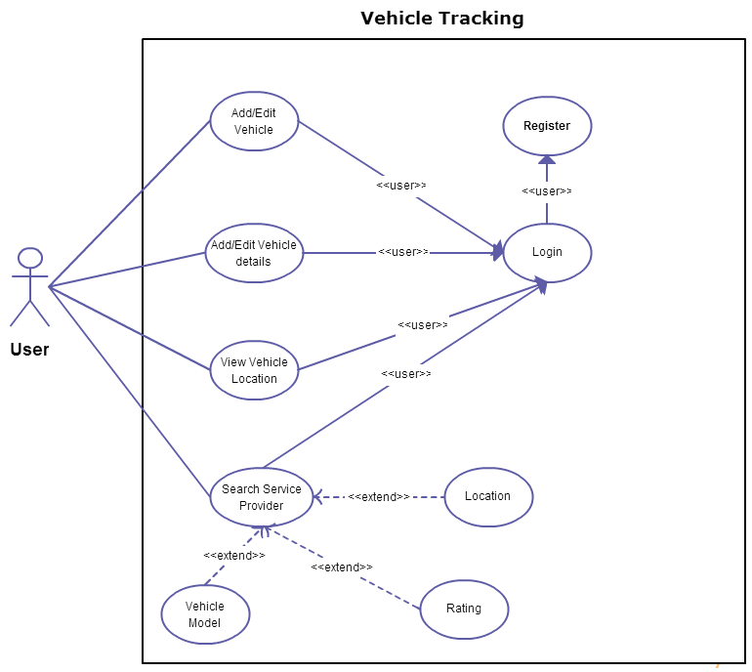

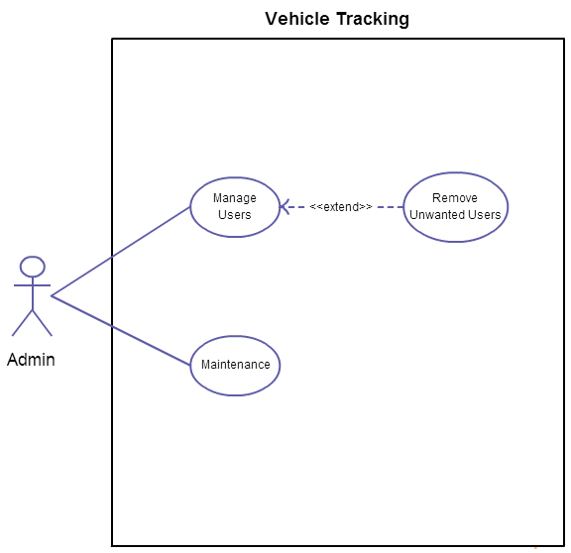

Figure 5.1:Use case diagram for Manage users

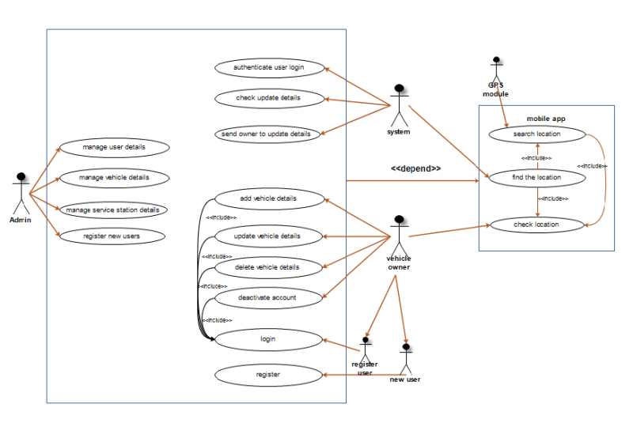Figure 5.2: Use case diagram toVTS

**5.3 Design**

System analysis describes what the system should do and System Design describes how the system should be constructed. In the design phase the required technologies have been identified to construct the system. These technologies mapped with the conceptual models created at the analysis phase.

This is the top level architecture of the system.

**System**

**DataBase**

GPS module

Web based user interface

Figure 5.3**:** Top level architecture of the system.

**5.3.1 Database Design**

Any good data storing mechanism requires for better performance of data input and output operation. In our system data base design is very important part. Because we have to store users details, vehicle details. Not only that, we have to send alert message to users. Fro this case we planned to used MySQL RDBMS. It is used for the system because it has very good features . Advantages of using MySQL as the database server are as follows.

* One of most popular database servers.
* Cross-platform compatibility.
* It's simplicity.
* High security capabilities.

The database was designed by using the ERD which is designed in the Analysis phase. Normalization rules were applied to normalize the database. In designing the database, the entities were converted to tables and attributes were converted to the fields. Database diagram and schema is given below.

5.3.1.1: ER Diagram

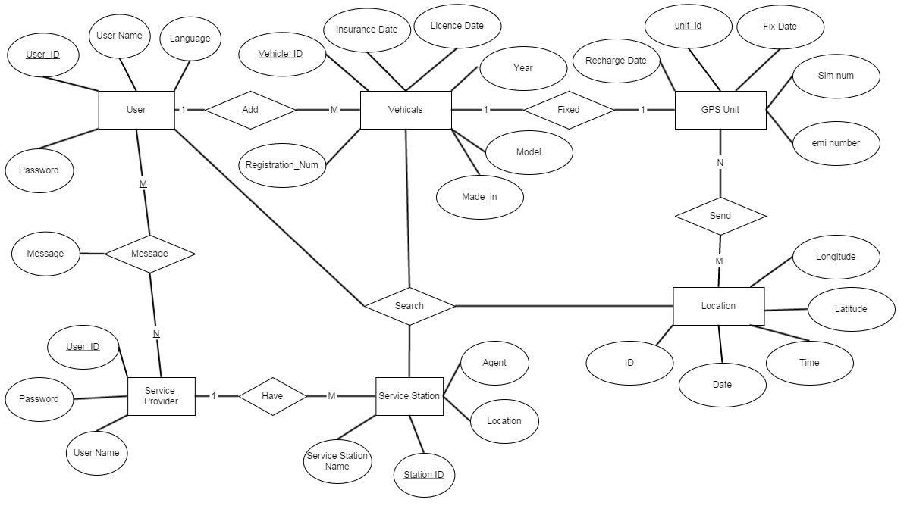

Figure 5.4: ER Diagram

**5.3.1.2 Data base schema**

**USER**

|  |  |  |  |  |
| --- | --- | --- | --- | --- |
| **USER** | User_ID | User_Name | Password | Status |

**VEHICLE**

|  |  |
| --- | --- |
| **VEHICLE** | Vehicle_ID |
|  | Registration_Num |
| Insurance_Date |
| License_Date |
| Year |
| Model |
| Made_In |
| Status |
| GPS_Unit_ID |

**Service station**

|  |  |  |  |  |  |
| --- | --- | --- | --- | --- | --- |
| Service_Station | SS_ID | SS_name | Agent | Location | Status |

**Administrator**

|  |  |  |  |  |
| --- | --- | --- | --- | --- |
| Admin | Admin_ID | name | password | Status |

**Images**

|  |  |  |  |  |  |
| --- | --- | --- | --- | --- | --- |
| Images | Img_ID | SS_ID | File_Name | File_Type | Status |

**GPS Unit**

|  |  |  |  |
| --- | --- | --- | --- |
| GPS_Unit | GPS_Unit_ID | Sim_Number | Emil_Number |

**Location**

|  |  |  |  |  |  |
| --- | --- | --- | --- | --- | --- |
| Location | Location_ID | Longitude | Latitude | Time | Date |

Figure 5.5:Data base schema

**5.3.2: Activity Diagram of the system**

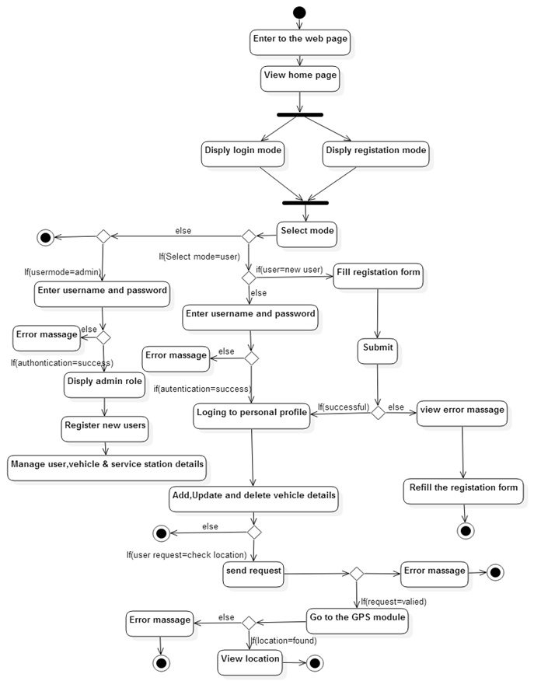

Figure 5.6: Activity Diagram

**5.3.3: Sequence Diagrams of the system**

**5.3.3.1 Service providers’ sequence diagram**

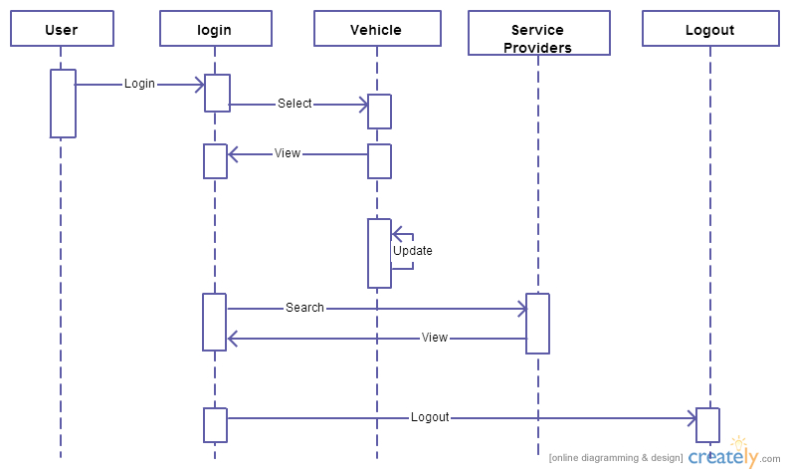

**5.3.3.2 Users sequence diagram**

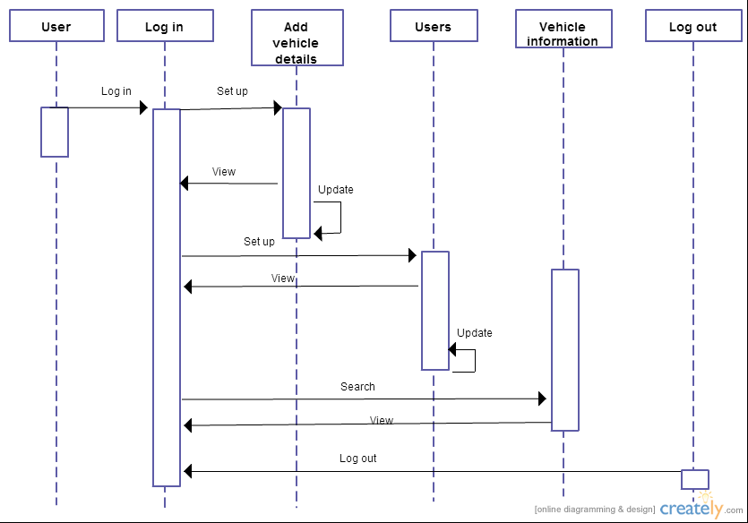

Figure 5.7: Sequence Diagrams

**5.4 Summary**

This chapter mainly focused on two parts of the project. There are Analysis and Design part. In the analyzing part describes how the requirements were gathered from the client and how they are analyzed. After analyzing the requirements they were visually modeled using UML and OOAD concepts. Use case model and the ERD were also discussed in this chapter. Then the chapter moved on to describe the design phase of the system. All the modules of the system were explicitly described and the interaction of the modules with each other was also discussed. Details like how the designed system is actually going to be implemented and up to how far it has been implemented will be discussed in the next chapter.

**Chapter 6**

**Implementation**

**6.1Introduction**

In the previous chapter we discussed how we have analyzed and designed our System. In this chapter we are going to describe about the implementation part of our system. This chapter will give you a wider knowledge on how each and every module in our program performs its functions and why those particular parts are there. This description contains all the details about our system.

## 6.2. Interfaces

As mention above these systems designed and develop with HTML5, CSS, and PHP there for it will work in any platform without any issue. Because of responsive web it can be adapt to any device and any resolution. Codeigniter PHP framework is using to code php codes because it is very easy to configure databases with codeigniter and also it is a light weighted framework therefore it is very effective when coming to these types of systems.

These days most of the people access web pages through their mobiles and therefore web pages need to be responsive. For that we use bootstrap to get responsiveness of our web site.

**6.3 Web based vehicle tracking system implementation**

Here we have five major steps for implement successful system to our client. They are

* Facilitate user to track the vehicle anywhere and view it in a map
* User friendly interface to the user which can record everything about vehicles
* Refer suitable service centers for the user
* System portability to any device
* Alerts and notification for the users

**6.3.1 Facilitate user to track the vehicle anywhere and view it in a map**

This is the main feature that we are offering for the users of the system, that any time anywhere anyone can get the location of the vehicle and view it in a digital map(Figure 6.1). The system allows the users to login, after a successful login the user can monitor the vehicle via map. The user can access the history of the vehicle where it had been. And the user can delete or add any details on his/her profile. But the admin is the user who can access with the system but only can manage the users and information not allowed to delete the history of any users details.

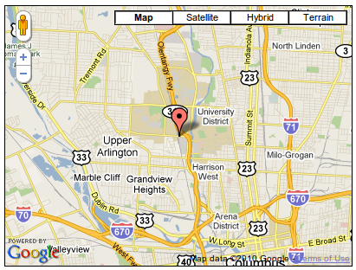

Figure 6.1 Google Map

**6.3.2 User friendly interface to the user which can record everything about vehicles**

Our system allows user to make a profile with their details of vehicle and can be access anytime easily. They also get access to edit, delete and insert details. They can access history of the profile. Already with access with the data that they entered they can get alerts informing immediate operation related to their vehicle.

**6.3.3 Refer suitable service centers for the user**

Our system refers the most suitable service center by using the GPS and GSM module trackers. Once the user log in to the system and update the location of the vehicle, system refer the service center that they needed by using the location of the vehicle and data included in the system of service providers.

**6.3.4 System portability to any device**

System requires access through any mobile device, So the features are enlarged to that point to cover most of the user of internet. So the users will get the advantage to access the system at anywhere.

**6.3.5 Alerts and notification for the users**

This is the feature that users get alerts informing future events related to the vehicle. So it will be helpful in managing the schedule.

**6.4 Summary**

In this chapter we mainly focus into how extend we have done so far, So in the implementation we have managed the client requirements and also we have done analysis and design of the system. And then to accomplish the system implementation according the steps that mentioned in this chapter.

**Chapter 7**

**Evaluation**

**7.1 Introduction**

In this chapter we are trying to recap the entire thing that we discuss in other chapter and how our system differs from other systems. Basically the testing, maintenance and further works.

**7.2 Testing**

Testing is the stage that evaluates the systems performances. First we have to check whether the logs in of various users areauthenticating accurately by the system. Normal user will enter user name and password and it should be stored in a database and access when that user login to the system. And the authorization each users differently.

Test the vehicle tracking whether the location details are sending the server accurately. And it should be stored and access when needed.

Test the alerts and notification work according to the date and time.

**7.3 Maintenance**

We are planning to develop this system by using php frame works that can be easily read and edited by any developer. Then accordingly any developer can add new features to the system and debugging.

**7.4 Security**

The major requirement of users of the system is security. We are planning to use encrypted version of users’ passwords to secure the details of users.

**7.5 Summary**

First we discussed about our project with our supervisor and took advice from her. Then we started to do our project work one by one. All group members of our group now on the track to implement our project. All the things are well managed. We think our basic implements are done. We already designed the database and now we started to design User interfaces and trying to use socket programing to track location and send it the server.

# Chapter 8

# Conclusion & Further work

## 8.1 Introduction

In previous chapters of this dissertation we have discussed about the Aim and Objectives, Problem in brief, proposed solution, implementation and technologies used in implementing the solution. This chapter includes conclusion of the dissertation and further improvements to this system.

## 8.2 Conclusion & Discussion of the project

Our main objective is to develop a real time vehicle tracking system to track everything about vehicles. Those location details are showed in a digital map where the vehicle owners can monitor their vechiles. The project titled “Automated vehicle tracing system” is a model for vehicle tracking unit with the help of GPS receivers and GSM modem. Vehicle Tracking System resulted in improving overall productivity with better fleet management that in turn offers better return on your investments. Better scheduling or route planning can enable you handle larger jobs loads within a particular time. Vehicle tracking both in case of personal as well as business purpose improves safety and security, communication medium, performance monitoring, fuel and power saving, effective fleet control, monitoring the delivery time, safer vehicle renting and increases productivity.

So in the coming year, it is going to play a major role in our day-to-day living. We have started the project as per the requirements of our project. Finally the aim of the project is to trace the vehicle is successfully achieved.

## 8.3 Further Improvements

Current system of capable of tracking vechiles in a real time digital map using the latest GSM & GPS technology to protect and monitor our car ,truck ,boat (moveable asset) virtually any where and then locate it to with in a few meter.

Above to our basic requirements,the following improvements are planned to add to this system later.

1. To use e-commerce to provide the user more access with payments

The system must include e-commerce concepts such as non-retailed paying online. Choose payment solutions. To choose payments for each service should be done after creating the system. Customers expect to be able to use their credit cards when purchasing online. To accept payment by card, you can apply for an online merchant account through your business bank or a third party. The application and approval process won’t be immediate. Expect to have your business credit report run and your site checked to see its up and running properly. Each company also charges its own transaction fees. Or we can use PayPal straightly.Signing up for PayPal allows bypass getting a merchant account. PayPal allows customers to pay directly through their bank accounts or by credit card. Expect to pay a flat rate monthly fee.

1. To promote a website with an android application which track everything about vehicle.
2. Add facility to monitor fuel level/ oil level of the vehicle.
3. Add facility to generate reports per vechicle and per month according to users’ requests.
4. Add facility to communicate with the other vechicle using system.

## 

## 8.4 Summary

Ridgecrest (pvt) Ltd needed a system to track the vechicles in a real time map. So we developed a system which uses location coordinates from GPRS enabled GPS device. Vehicle information like location details, speed, distance traveled etc. can be viewed on a digital mapping with the help of a software via Internet. Even data can be stored and downloaded to a computer from the GPS unit at a base station and that can later be used for analysis. This system is an important tool for tracking each vehicle at a given period of time and now it is becoming increasingly popular for people having vechicles and hence as a theft prevention and retrieval device.

There are systems which are currently operating in local and foreign countries to track vehicles in a real time manner. The system we developed is having all the core functions of those systems and VTS can be developed and implemented using a low cost budget than those systems. And VTS can also be considered as a fully customizable system than the other existing system.

In this document we discussed about the overall project and technologies. Then state about the further works which have to be done in the future. Chapters are end and the next section mention the references which were used and appendix A describes the individual contribution to the project.

# References

1. <http://en.wikipedia.org/wiki/GSM>
2. <http://en.wikipedia.org/wiki/GPRS>
3. <http://en.wikipedia.org/wiki/GPS>
4. <http://www.teknotrack.lk/>
5. <http://www.accura-tech.com/gps_tracking.php>
6. <http://en.wikipedia.org/wiki/Transmission_Control_Protocol>
7. <http://lanagps.com/Media/Default/Doc/VT300_User_Manual.pdf>
8. <http://en.wikipedia.org/wiki/Network_socket>
9. <http://www.php.net/manual/en/index.php>
10. <http://www.w3schools.com/js/>
11. <https://maps.google.com/>

# Appendix A

# Individual Contribution

**Wijerathna K.H.D.D.(125078D)**

As the team leader, I set goals and objectives to my team and divided tasks among my team members, making sure that they were accomplished on schedule. I also developed various algorithms for the server and other various functions and features of the web based vehicle tracking system and to process data received from the GPS devices and stored in the data base, to make the system more informative and to analyze and present data in a user friendly manner.

And I got the major requirement of the client, that is tracking vehicle location and send it to the server and access with the database. When I go through this requirement we initially thought that the arduino circuit is suitable for this, but it is much cost, then the separate GSM and GPRS modules are cost effective. If we use Arduino, it flexible to handle data input and output. GSM only get the location by using longitude and latitude, GPRS get the location exactly, it is very accurate. The process is to get the location details such as venue, date and the longitude and latitude. Then send the details via URL (HTTPS) to the server side. This system is going to be done by using php, javascript, html, css embedded Google maps.

The GPS-GPRS-based tracking system is a system that makes use of the Global Positioning System GPS to determine the precise location of a vehicle to which the device is attached. When a large number of objects or vehicles were spread all over the ground, the owner of corporation needs to keep track for fuel saving, security purposes etc. A tracking system is required to determine the location of any object at any given time and the distance travelled. Also, the need for a tracking system in users vehicle is used to prevent any kind of theft since police can use tracking reports to locate a stolen vehicle location GPRS and GPS based tracking system will provide effective, real time vehicle location report. A GPS-GPRS based tracking system gives all the specifications about the location of a vehicle. The system utilizes geographic position and time information from the Global Positioning Satellites.

The system uses an On-Vehicle Module consists of GPS receiver and GSM modem, the device resides in the vehicle to be tracked. In order to track the movement of the vehicle Google Maps used for mapping the location. The GSM modem fetches the GPS location and sends it to the server using GPRS.

Now I am doing this function step by step and handling overall stuff of the project. The specialty in our team is we have divided the requirements with the team and each one is responsible for their work. I should only lead them into right task at right time. And manage the developing process.

I designed the ER diagram and my friends create the database schema, and helped in writing the project reports and to analyze the requirements into five major points.

**P.M.C.N Jayawardana (125021 A)**

When we got this project as our Industry Based Project we were asked to implement this project using the modern Frameworks. At that moment most of us did not have a clear idea about any of these frameworks or technologies. Right from the start we had to learn all these technologies by ourselves in order to implement our project. Since learning all these frameworks was bit harder, we divided them among ourselves. I got the database parts which have our project. And I studied what is the technology we should use, how they implement from a unique way. And I also researched other technologies parts which required to our project and also helped to my other group members to search information about project’s requirements of our project. In this report my responsibility was found other similar works regarding to our project. And I compared our project with others works. As well as in design part I did help to create UML diagrams as well. Especially I created UML activity diagram which we want and help to do other parts of entire project. This was my individual contribution of our project.

**Kanchanamala M.A.D (125027X)**

When we started the industry based project, which is the vehicle tracking system and web based Management System. After approved our project, we discussed what we have to do. Then we gather information about the existing vehicle tracking systems. We compare them with our project. Then we all come to one stand, and start to gather and analysis information that are we want.

As a team we discussed to divide work among ourselves to make the process much easier. So we divide our project into mainly five parts. I got to make a mobile app. Firstly I haven’t any idea how to make this app, which language wants to use or anything. As a girl I have to do lots of works to do my part. So I start my work, by searching information. Then I decide to create app by using android language.

Then I search about the android and its technology. How we can use it, when we use it and what is android. After getting some idea about the android, I compare it with our project. What I have to do and how should I do my part, how it help to make our project successful. I refer Google, and you tube. I start my works doing some tutorials.

I help to do database part also and I draw er-d and use case diagram also.Not only that I help to my group as I can. I wish that I would be able to use my knowledge more in the fore coming developments in the project.

**A.L.F.Rizna (125056 J)**

My part of the project was to develop an application to log details of vehicles. If the user need to keep the vehicle’s details in an automated system which can be easily access with, so the system should capable for create, edit, update user’s vehicle details in the website and in the application for mobiles. For an instance vehicle related details are license, insurance, lease, and the legal companies for vehicles etc. And if the user needs to know about the all vehicle details, the application must design to show then when you put the mouse point on the relevant vehicle. Like that I decided to design it in a user friendly manner. To perform the above functionalities I suggested PHP is the most suitable scripting language for this purpose. It becomes much easier because we have learnt this language as a subject in our course module.

To achieve our objectives I am learning new things on web designing technologies and advanced web programming using languages such as PHP, JavaScript & Ajax etc. I referring video tutorials related to creating web sites using joomla also and self-studying them.

I helped to my group members to write the interim report and drawing diagrams. we are hoping to finish it really soon and achieve our target…

**Afeefa M.J. (125080c)**

At first we have no idea at all how to implement the technologies to our project. So we had to learn from the basic things in order to continue our project. We decided to search everything ourselves regarding the system and we divided the as it is easy to complete before the deadline. I got the web application part to implement service stations to search if it needs for the user. Beyond that I search what are the usages of technologies when we are implementing our project. How these technologies adopted is an important part in the system. Next I included our approach towards the system. How the system is working while implementing these technologies is included in this part. As well as I helped my colleagues to the other parts.